IT351 Computer Networks — Phase 1 Mid Progress Report

1. Work Completed This Period
Packet Tracer Installation Screenshot:
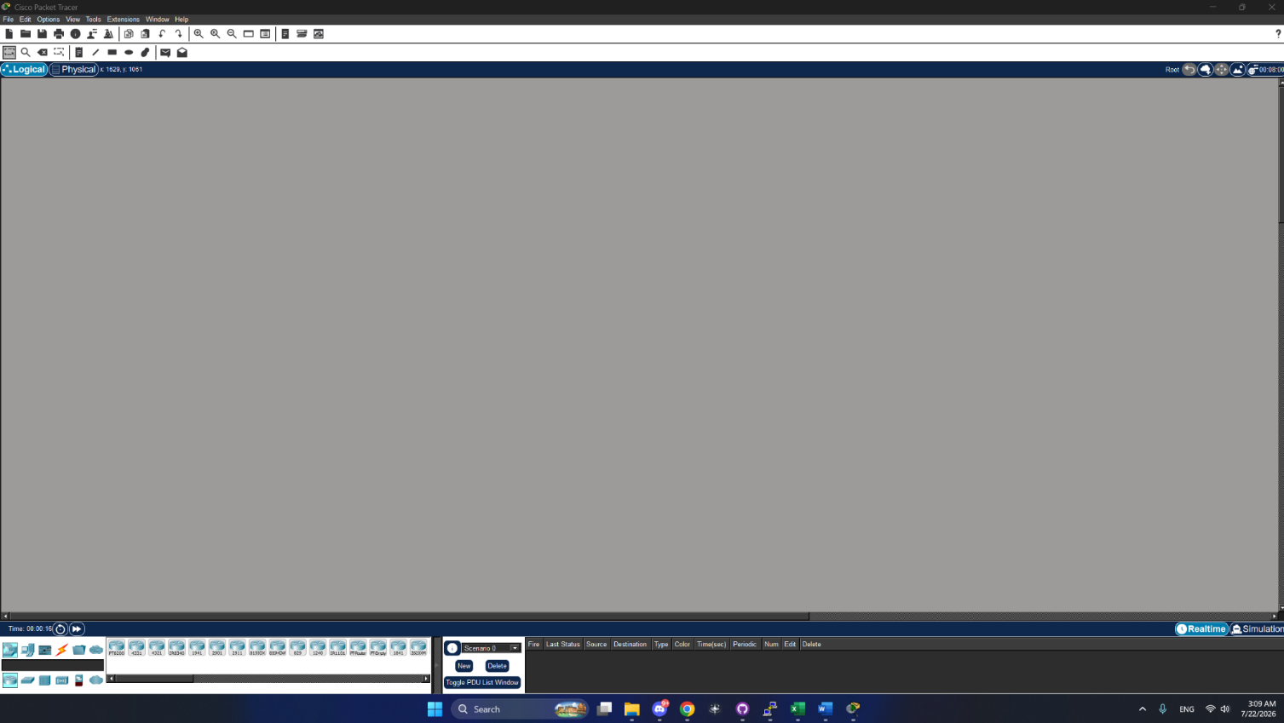

Objectives and Advantages of Using Packet Tracer for This Project:
Packet Tracer was an important tool that allowed our group to build and test the campus network without real routers or switches for this project. Its main purpose was to give us a safe environment to test the LANs' configuration and WAN link establishment before we put it into practice on real equipment. One thing we found was it immediately shows if a link is working or not, so we could see right away if an interface was set up properly. This also gave us the ability to ping the connection to verify that the network was actually working end-to-end.

2. One Key Decision Made During This Period
One key decision our group made during this period was how to divide the network build across the four of us. We split the work by function and not by campus so each member was responsible for a certain part of the configuration: Ali built the total topology and assigned the static IPs for the Admin and Lab PC’s, Emad set up the Library and Faculty PC’s and activated the GigabitEthernet0/0 interface of Router 1, Salem will set up the GigabitEthernet0/1 and finish the rest of the configuration of Router 1 and Router 2, and Abdullah will set up the serial interface of Router 2 and the static routes on both routers. Then Ali will test the connectivity by ping and exporting the configuration files. We decided on this split so that each person could focus on and understand one part of the setup fully.

3. One Problem Encountered
One problem we had was that after setting the IP addresses on one of the router interfaces, the interface was still administratively down and was not forwarding traffic. Upon checking the configuration we found that the “no shutdown” command was not configured. By default all router interfaces are shut down, therefore it needs to be manually enabled. We ran "no shutdown" on the affected interface and it came up (verified with "show ip interface brief", which showed the status change to up/up) and connectivity worked as expected.
Status: Resolved

4. Plan for Next Period
• Salem to configure Router 1's GigabitEthernet0/1 interface and complete the remaining configuration on Router 1 and Router 2
• Abdullah to configure Router 2's Serial0/3/0 interface and set up the static routes (ip route) on both routers
• Ali to verify PC-to-PC ping across the WAN, confirming an end device in one campus (e.g. a Lab PC) can successfully reach an end device in the other campus (e.g. a Faculty PC), not just router-to-router connectivity
• Wait for Phase 2 instructions to be released and begin planning accordingly

5. Group Member Contributions
Name | Contribution
Ali | Built the network topology; configured static IPs for the 3 Admin Office PCs and 3 Computer Lab PCs.  Also assigned to test connectivity with ping and export router configuration files once Salem and Abdullah done their tasks, planned for Phase 2.
Emad | Configured the 3 Library PCs and 3 Faculty Office PCs; configured and brought up Router 1's GigabitEthernet0/0 interface.
Salem | Assigned to configure Router 1's GigabitEthernet0/1 interface and complete remaining Router 1/Router 2 configuration; not yet started, planned for Phase 2
Abdullah | Assigned to configure Router 2's Serial0/3/0 interface and static routes (ip route) on both routers; not yet started, planned for Phase 2

Project Artifacts

- Live report document: https://docs.google.com/document/d/1aiy0MN4m11UmIvm8A8T-EG055DWcjue5Kk3mtQ-akI4/edit?usp=sharing

- GitHub repository: https://github.com/PRQAE/IT-351-Project.git

